Day 1 A: Days of the Week
What do the students do everyday/week?
Review days of the week:
Monday | Tuesday | Wednesday | Thursday | Friday | Saturday | Sunday
today | tomorrow | yesterday | the weekend

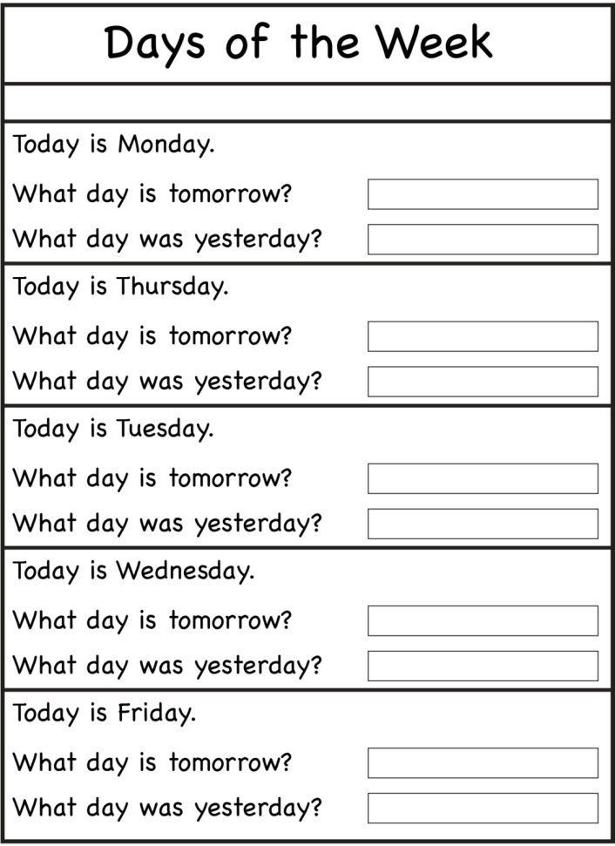
Which days are for homework?
Review subjects with students. What is your favorite subject?
math | science | English | art | geography | music

What do you do on the weekend?
dance | read | ride a bike | play computer games | swim | watch TV

Activities: Have students make a weekly schedule in English.
Months of the Year
Review the months with the students.
When is your birthday?
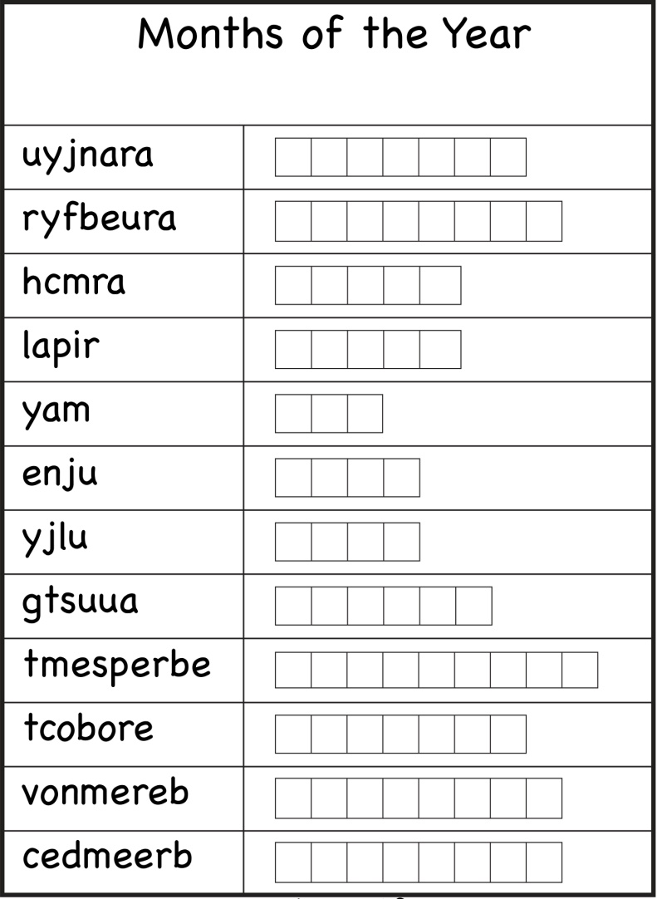
Activity: 12 Months Scramble
Write a month on a sticky note and post it on a student’s back. Each student will have a month. Mix the students up and have them get into ascending order. Students cannot talk or give hand gestures while they get into order. Time the students and see how long they take.

